CSC2058 Peer Assessment 1: Back from the Brink

This Assessment Document is intended to provide you and your assessor with an overview of each group member’s involvement delivery of the CSC2058 Project.

Each group should complete one Assessment Document and its content must be agreed by all group members. The completed form should be included at the start of your group’s PDF report. ***Don’t forget to fill in the Group Number.***

There are two main parts to the Assessment Document – the Evaluation and the Declaration. Both parts must be completed – otherwise your group’s report will not be marked. Arrange a group meeting to discuss the evaluation, and see the note below!

|  |  |  |  |  |
| --- | --- | --- | --- | --- |
| **Evaluation** | Group Number: 40 | | | |
| Name | Contribution to team-working and motivation1 | Contribution to PDF Report 1 1,2 | Contribution to Interim Demo1,2 | **Peer Score**  (Range 85 – 115) |
| Daniel Mason | 5 | 5 | 5 | 115 |
| Niamh McLarnon | 5 | 5 | 3 | 114 |
| Omar Ahmed Bashah | 4 | 4 | 1 | 105 |
| Charlotte Bisp | 3 | 3 | 1 | 95 |
| Craig Mulligan | 2 | 2 | 1 | 90 |
| Michael Kennedy | 2 | 2 | 1 | 90 |

1Values for contribution: 1 = Minimal Contribution; 2 = Reasonable Contribution; 3 = Good Contribution; 4 = Very Good Contribution; 5 = Excellent Contribution

2This value should consider contributions in the round – direct contributions to required deliverables, and contributions that have made the deliverables possible.

|  |  |  |
| --- | --- | --- |
| **Declaration**  “I declare that I have read the Queen's University regulations on plagiarism, and that any contribution I have made to the attached submission is my own original work, except for any elements that I have clearly attributed to third parties. I understand that this submission will be subject to an electronic test for plagiarism and will also be subject to the University’s regulations concerning late submission if it is received after the deadline.” | | |
| Name | Date | Confirmation *(use the words shown in the example below!)* |
| Daniel Mason | 06/12/2020 | I agree to the terms of the declaration |
| Niamh McLarnon | 06/12/2020 | I agree to the terms of the declaration |
| Omar Ahmed Bashah | 07/12/2020 | I agree to the terms of the declaration |
| Charlotte Bisp | 07/12/2020 | I agree to the terms of the declaration |
| Craig Mulligan | 07/12/2020 | I agree to the terms of the declaration |
| Michael Kennedy | 07/12/2020 | I agree to the terms of the declaration |

**PDF Report Group 40**

**The Problem and the Early Solution**

**Use Case Requirements Specification and Planning**

## Use case diagrams

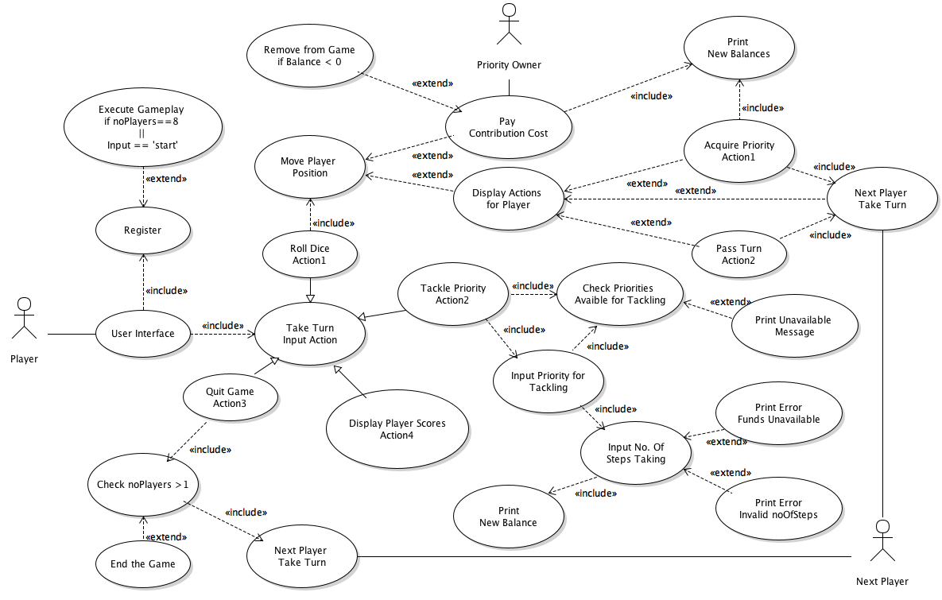**System Overview Use-Case** [D.M.; N.M.] Peer Reviewed [O.B.]

[N.M.; D.M.]

|  |  |
| --- | --- |
| Flow of Events for the Overall System use-case | |
| Objective | To register players and run the game until there is a winner |
| Precondition | The program must be run |
| Main Flows | 1. The player registration starts as system is launched 2. The players take turns 3. The players perform actions on squares 4. The players are eliminated when balance reaches zero 5. The players are eliminated till there is only one 6. The program ends |
| Alternative Flows | At 2, the players may select to quit. In this case, the game will be closer to ending. |
| Post- Condition | A winner must be displayed |

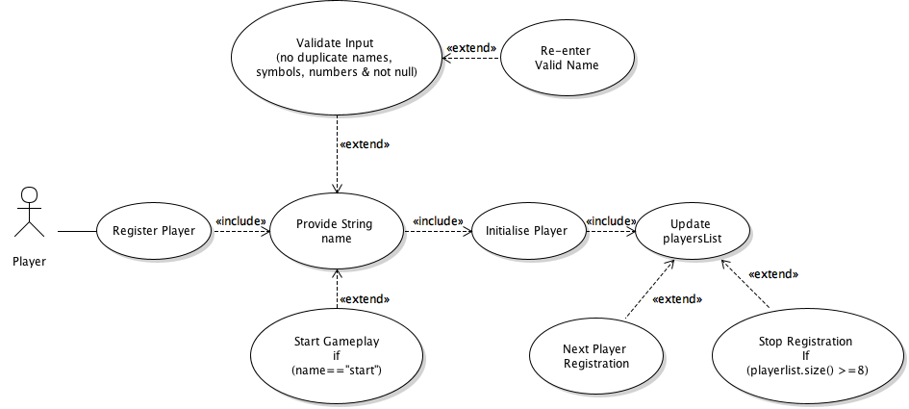**Register Player Use-Case** [D.M.] Peer Reviewed [O.B.]

[N.M.]

|  |  |
| --- | --- |
| Flow of Events for the Register Player use-case | |
| Objective | To register a new player in the game data |
| Precondition | The number of players already registered must not exceed 8 |
| Main Flows | 1. The player registration starts as system is launched 2. The player is asked to provide name 3. The player enters a name 4. The player is initialised as a Player object 5. The player list is updated 6. The next player starts registration |
| Alternative Flows | At 3, the player may enter a name that is invalid. In this case the player will be asked to enter re-enter a valid name.  At 3, the player enters “start” as a name the registration will cancel and gameplay will start.  At 5, there may already be the maximum number of players already registered in the game. In this case the registration is stopped.  At 6, the player list reaches 8, the maximum amount, in this case the gameplay will start. |
| Post- Condition | The player is registered to the game and the number of players is updated |

**Take Turn Use-Case** [D.M.; N.M.] Peer Reviewed [O.B.]

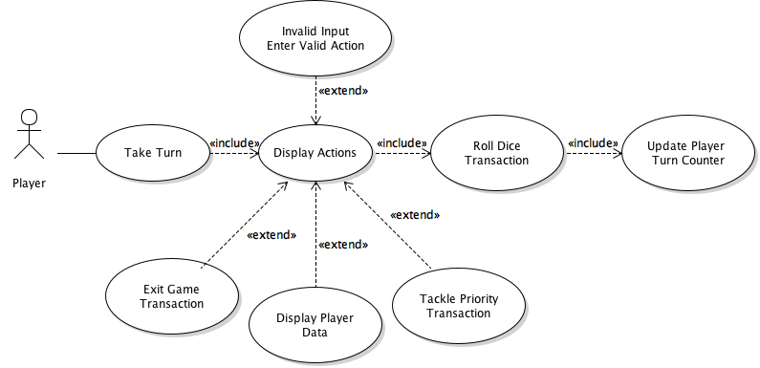

[N.M.; D.M.]

|  |  |
| --- | --- |
| Flow of Events for the Take Turn use-case | |
| Objective | For the player to be able to take their turn when it is their go in the game |
| Precondition | It must be the player’s turn within the game’s turn counter |
| Main Flows | 1. The game displays actions that the player can take. 2. The player selects the action/actions they wish to take during their turn 3. The player ‘rolls the dice’ and ends their turn |
| Alternative Flows | At 2, the player enters and invalid choice. In this case they will have to re-enter a new choice until it is valid |
| Post- Condition | The player has taken their turn and the player turn counter is updated |

**Roll Dice Use-Case** [D.M.] Peer Reviewed [O.B.]

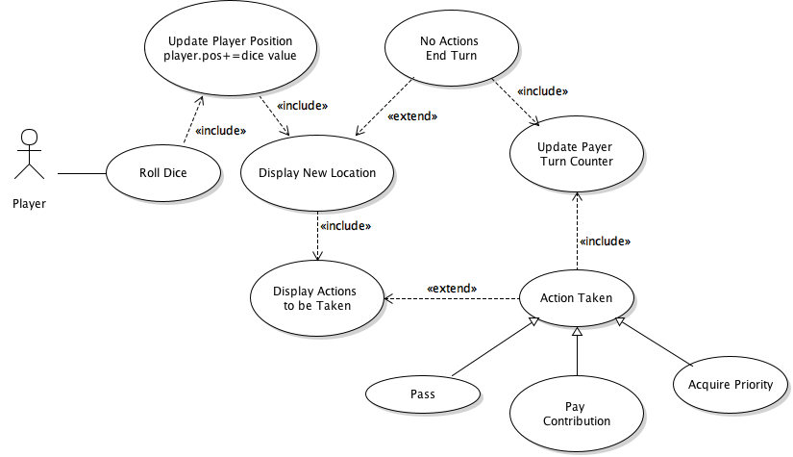

[N.M.] Peer Reviewed [O.B.]

|  |  |
| --- | --- |
| Flow of Events for the Roll Dice use-case | |
| Objective | For the player to roll the dice to move to their next position |
| Precondition | It must be the players turn for them to be able to roll the dice |
| Main Flows | 1. The player selects to roll the dice 2. The dice produces a number to show the player how many locations on the board they will move 3. The player’s position is updated 4. The board game displays the location 5. The game displays actions to be taken. 6. The player selects the action to be taken |
| Alternative Flows | At 4, the player has landed at a square with no actions. In this case main flow 6 is skipped |
| Post- Condition | The player turn counter is updated and the next player’s turn begins |

**Acquire Priority Use-Case** [D.M.] Peer Reviewed [O.B.]

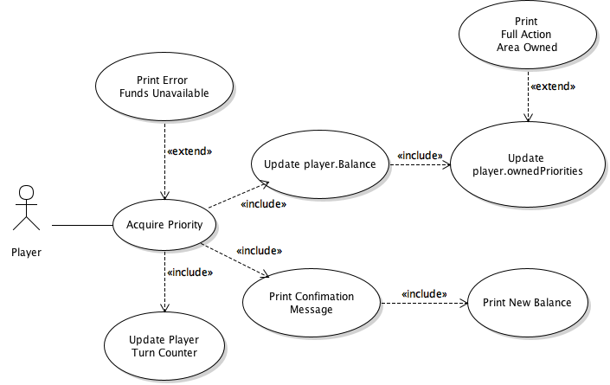

[N.M.]

|  |  |
| --- | --- |
| Flow of Events for the Acquire Priority use-case | |
| Objective | To acquire an already existing priority within the game |
| Precondition | This priority must be unowned |
| Main Flows | 1. The player lands on priority 2. The player wants to acquire priority 3. The player purchases the priority 4. The player’s balance is updated 5. The player priority list is updated |
| Alternative Flows | At 2, the player may not have enough funds. In this case this player is unable to acquire the property.  At 5, the player has acquired a full action area. In this case, the player will be notified and allowed to tackle it. |
| Post- Condition | The priority is acquired and players that now land on it owe a contribution |

**Contribution Use-Case** [D.M.] Peer Reviewed [O.B.]

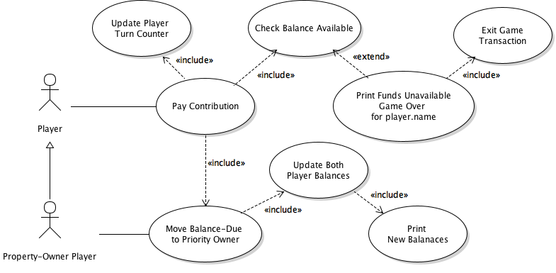

[N.M.]

|  |  |
| --- | --- |
| Flow of Events for the Contribution Transaction use-case | |
| Objective | The player must pay the contribution |
| Precondition | The player must have landed on an already owned priority by another player- property owned player |
| Main Flows | 1. The player lands on a priority 2. The player pays the contribution 3. The player’s contribution is transferred to the Priority Owner. 4. The balance of the player and the priority owner are updated |
| Alternative Flows | At 2, the player may not have sufficient funds. The player will be removed from the game |
| Post- Condition | The contribution is paid |

**Tackle Priority Use-Case** [D.M.] Peer Reviewed [O.B.]

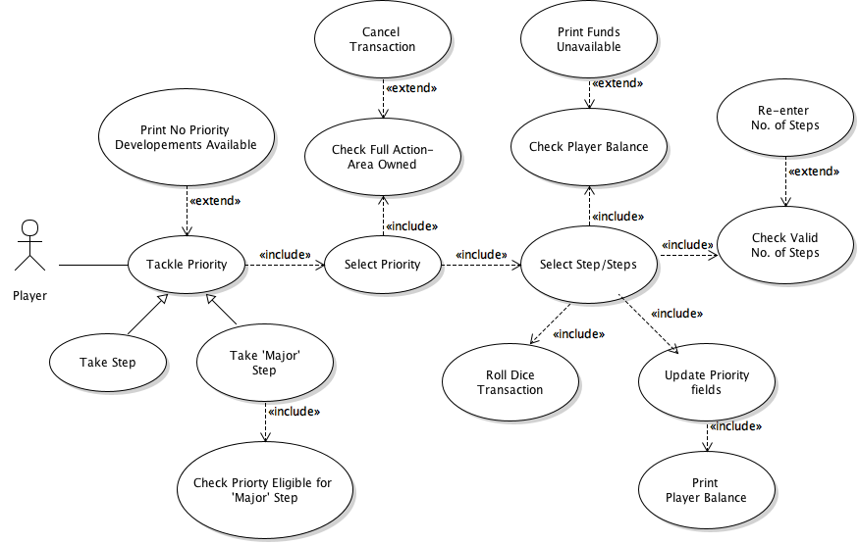

[N.M.]

|  |  |
| --- | --- |
| Flow of Events for the Tackle Priority Transaction use-case | |
| Objective | To develop priority |
| Precondition | The player must own the entire action area which the priority they want to update is included in |
| Main Flows | 1. The player chooses to tackle priority 2. The player selects priority 3. The player selects how many steps 4. The priority is updated |
| Alternative Flows | At 1, there is no priority developments available. In this case, the game will print no priorities available.  At 2, the player may not fully own the action area. In this case the transaction is cancelled  At 3, the player may have insufficient funds to tackle the priority. In this case the player is unable to tackle the priority and main flow 4 is skipped. |
| Post- Condition | The priority is updated |

**Remove Player Use-Case** [D.M; N.M.] Peer Reviewed [O.B.]

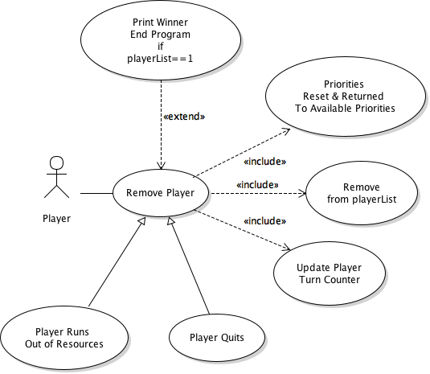

[N.M.; D.M.]

|  |  |
| --- | --- |
| Flow of Events for the Remove Player use-case | |
| Objective | To remove player from the board game |
| Precondition | It must be the players turn |
| Main Flows | 1. The player has selected to remove player 2. The removed player’s priorities are reset and returned 3. The player list is updated |
| Alternative Flows | At 2, the player may have no priorities owned. In this case there may be no priorities to be reset.  At 3, the player list may now only contain one player. In this case the game will end. |
| Post- Condition | The player is removed, and the total player amount is decreased. |

**Pass Go Use-Case** [D.M.]

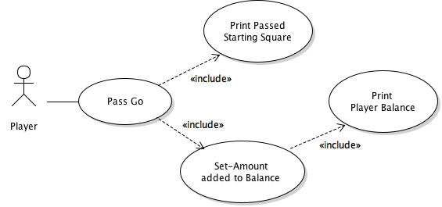

[N.M.]

|  |  |
| --- | --- |
| Flow of Events for the Pass Go Transaction use-case | |
| Objective | To pass starting position of the board |
| Precondition | It must be the players turn |
| Main Flows | 1. The player lands on or passes go (start square) 2. The player is notified they passed the starting square 3. The set amount is added to the player’s balance 4. The player’s new balance is printed |
| Alternative Flows |  |
| Post- Condition | The player passes go |

## Gantt chart

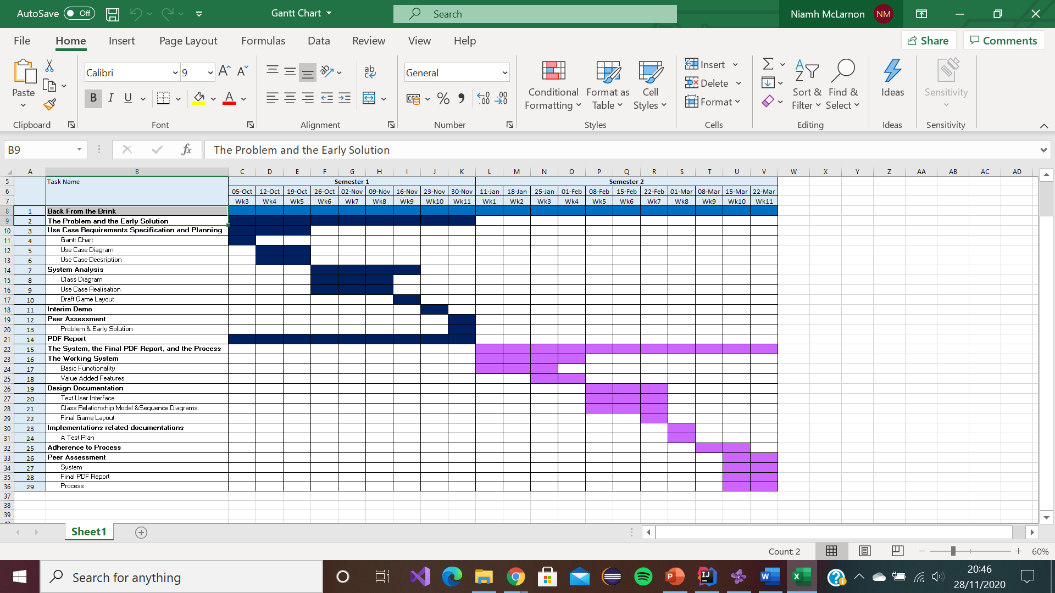[N.M.]

# System Analysis

## Class diagram

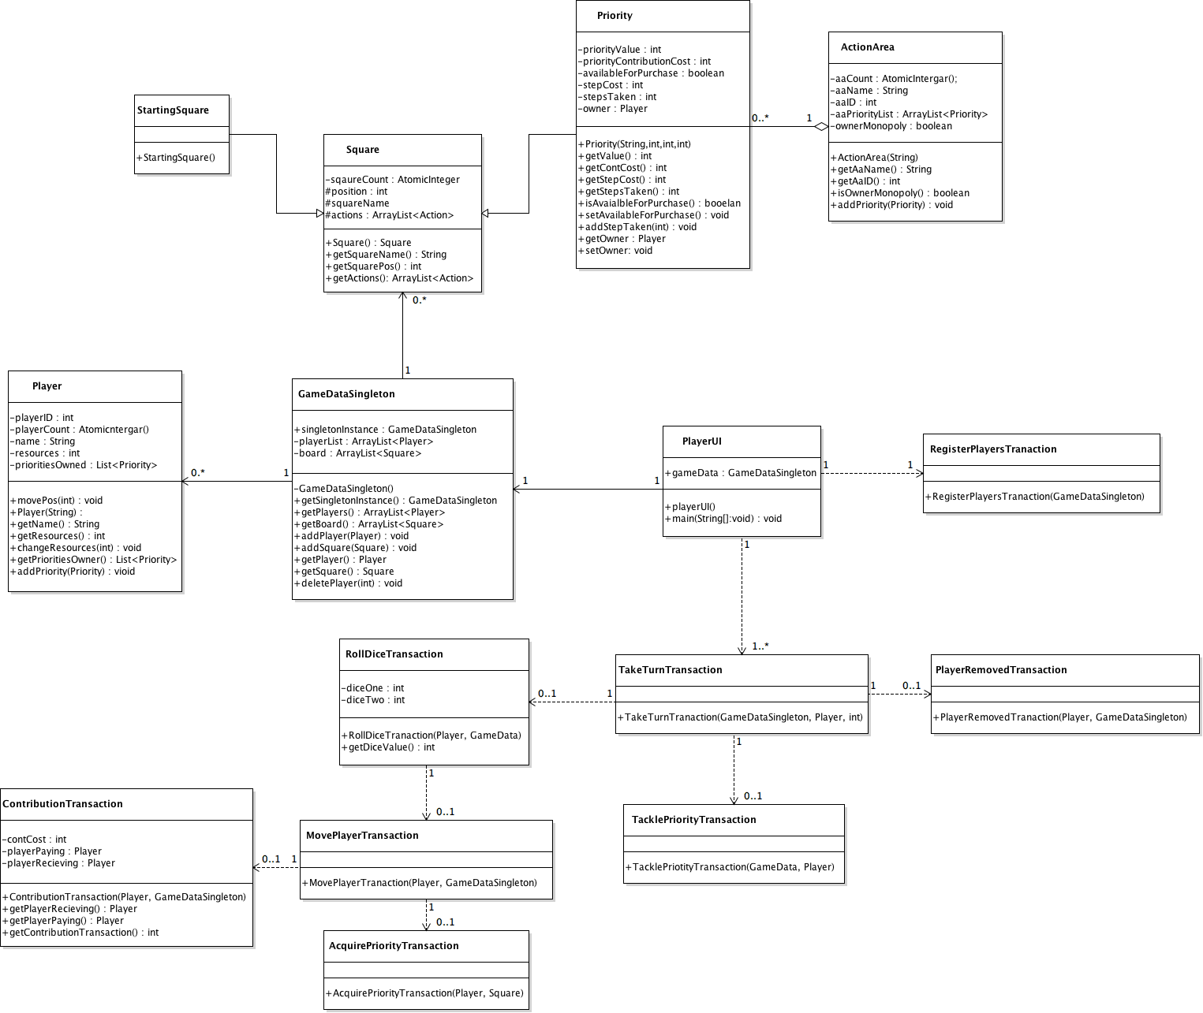[D.M.; M.K.]

## Use case realisations

**Register Player Use Case Realisation** [D.M; N.M.]

* This describes the interaction among the player and the objects involved in registering them as a Player

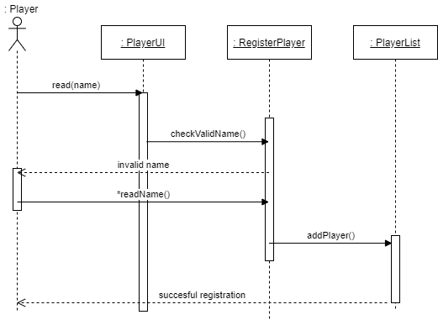

**Take Turn Use Case Realisation** [D.M; N.M.]

* This describes the interaction between the player and the objects involved in taking their turn

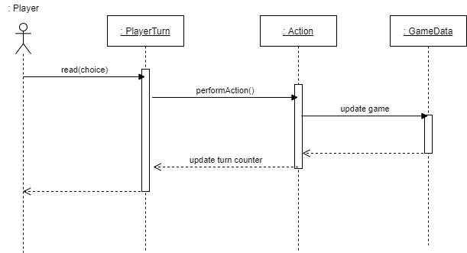

**Roll Dice Use Case Realisation** [D.M; N.M.]

* This describes the interactions between the player and the Action of rolling the dice

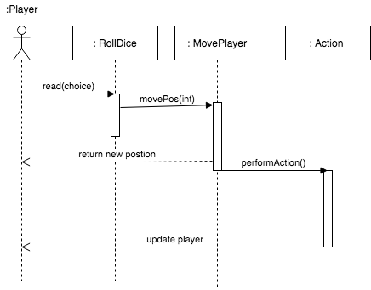

**Acquire Priority Use Case Realisation** [D.M; N.M.]

* This describes the interactions between the player and objects involved in acquiring a priority for the player

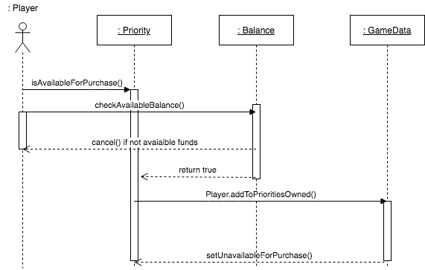

**Contribution Use Case Realisation** [D.M; N.M.]

* This describes the interactions between the player, the priority, and the priority owner when the player lands on a owned square

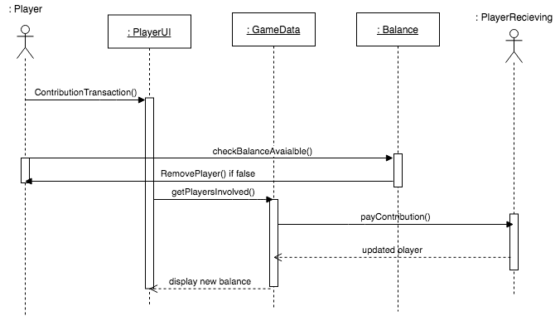

**Tackle Priority Use Case Realisation** [D.M; N.M.]

* This describes the interactions between the player and the game objects when addressing/tackling a priority

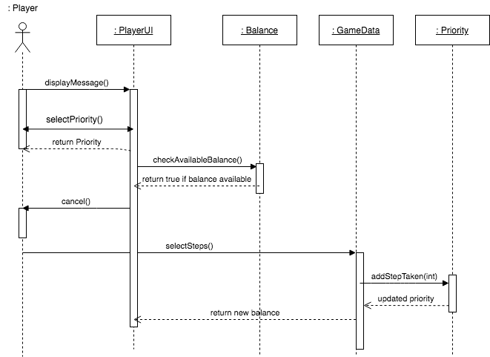

**Remove Player Use Case Realisation** [D.M; N.M.]

* This describes the interactions between objects when a player is removed from the game for leaving or running out of resources

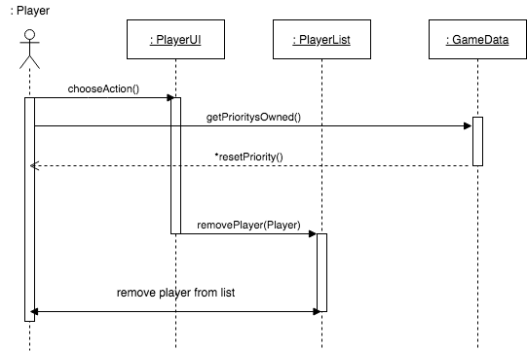

**Pass Go** **Use Case Realisation** [D.M; N.M.]

* This describes the interactions between the payer, board and balance when a player circles the whole board

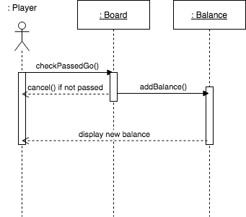

## Draft game layout

**Action Areas**

|  |  |  |
| --- | --- | --- |
| **Animal Organisations Area**  (2) IUCN  (4) World Animal Protection  (5) International Animal rescue | **Wildlife Organisations**  (6) The Wildlife Trust  (8) Defenders of wildlife  (9) World Wildlife fund (WWF) | **Aquatic Conservation Area**  (11) Sea turtle foundation  (13) Marine conservation society |
| **Safari Conservation Area**  (14) Save the elephants  (15) International Rhino foundation  (17) African wildlife foundation | **Domestic Pets Conservation Area**  (18) Four Paws UK  (20) RSPB  (21) APA (animal protection agency) | **Animal Protection Area**  (22) PETA  (24) RSPCA |

**[C.B.,N.M]**

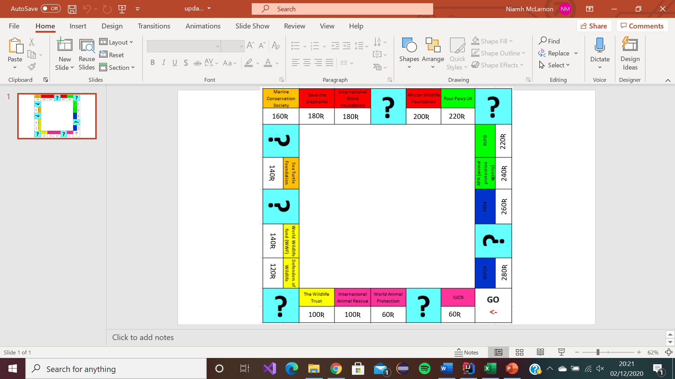**Note: ? represent ‘Added-Value Feature’ Squares**

|  |  |  |  |  |  |
| --- | --- | --- | --- | --- | --- |
| **Square 1**  **Pass go** | **Square 2**  **Colour Pink**  **“IUCN”** | **Square 3**  **Resource Sq.** | **Square 4**  **Colour Pink**  **“WAP”** | **Square 5**  **Colour Pink**  **“IAR”** | **Square 6**  **Colour Yellow**  **“Wildlife Trust”** |
| Collect 200 Ʀ | Purchase cost 60R  Step Cost 30Ʀ  Contribution Costs: 2R  1Step(10R), 2Step(30R)  3Step(90R)  Maj Step cost 250R | Collect 10R | Purchase cost 60R  Step Cost 30R  Contribution Costs: 4R  1Step(20R), 2Step(60R),  3Step(180R)  Maj Step cost 450R | Purchase cost 100R  Step Cost 50R  Contribution Costs: 6R  1Step(30R), 2Step(90R),  3Step(270R)  Maj Step cost 550R | Purchase cost 100R  Step Cost 50R  Contribution Costs: 6R  1Step(30R), 2Step(90R),  3Step(270R)  Maj Step cost 550R |

|  |  |  |  |  |  |
| --- | --- | --- | --- | --- | --- |
| Square 7  Resource Sq. | Square 8  Colour Yellow  “DoW” | Square 9  Colour Yellow  “WWF” | Square 10  Resource Sq. | Square 11  Colour Orange  “Sea Turtle F” | Square 12  Resource Sq. |
| Collect 50R | Purchase cost 120R  Step Cost 60R  Contribution Costs:  8R  1Step(40R), 2Step(100R),  3Step(3000R)  Maj Step cost 600R | Purchase cost 140R  Step Cost 70R  Contribution Costs:  10R  1Step(50R), 2Step(150R),  3Step(450R)  Maj Step cost  750R | Collect 100R | Purchase cost 140R  Step Cost 70R  Contribution Costs:  10R  1Step(50R), 2Step(150R),  3Step(4500R)  Maj Step cost 750R | Collect 170R |

|  |  |  |  |  |  |
| --- | --- | --- | --- | --- | --- |
| Square 13  Colour Orange  “Marine” | Square 14  Colour Red  “Elephants” | Square 15  Colour Red  “Rhino” | Square 16  Resource Sq. | Square 17  Colour Red  “AWF” | Square 18  Colour Green  “Four Paws” |
| Purchase cost 160R  Step Cost 80R  Contribution Costs:  12R  1Step(60R), 2Step(180R),  3Step(500R)  Maj Step cost 900R | Purchase cost 180R  Step Cost 90R  Contribution Costs:  14R  1Step(70R), 2Step(200R),  3Step(550R)  Maj Step cost 950R | Purchase cost 180R  Step Cost 90R  Contribution Costs:  14R  1Step(70R), 2Step(200R),  3Step(550R)  Maj Step cost 950R | Collect 200R | Purchase cost 200R  Step Cost 100R  Contribution Costs:  16R  1Step(80R), 2Step(220R),  3Step(600R)  Maj Step cost 1000R | Purchase cost 220R  Step Cost 110R  Contribution Costs:  18R  1Step(90R), 2Step(250R),  3Step(700R)  Maj Step cost 1050R |

|  |  |  |  |  |  |
| --- | --- | --- | --- | --- | --- |
| Square 19  Resource Sq. | Square 20  Colour Green  “RSPB” | Square 21  Colour Green  “APA” | Square 22  Colour Blue  “PETA” | Square 23  Resource Sq. | Square 24  Colour Blue  “RSPCA” |
| Collect 250R | Purchase cost 220R  Step Cost 120R  Contribution Costs:  18R  1Step(90R), 2Step(250R),  3Step(700R)  Maj Step cost 1050R | Purchase cost 240R  Step Cost 120R  Contribution Costs:  20R  1Step(100R), 2Step(300R),  3Step(750R)  Maj Step cost 1100R | Purchase cost 260R  Step Cost 130R  Contribution Costs:  22R  1Step(110R), 2Step(330R),  3Step(800R)  Maj Step cost 1150R | Collect 300R | Purchase cost 280R  Step Cost 140R  Contribution Costs:  24R  1Step(120R), 2Step(360R),  3Step(850R)  Maj Step cost 1200R |

**Appendix**

# Minutes for CSC2058 Project: 20 Minutes Week commencing: 12/10/2020

# Date of this minute­­­­­: 13/10/2020

The following team members were present on Teams (if not Teams, indicate platform) when minutes were discussed:

|  |  |
| --- | --- |
| Name (printed/typed) | Signature (agreed bitmap or initials) |
| Daniel Mason | DM |
| Niamh McLarnon | NML |
| Craig Mulligan | CM |
| Michael Kennedy | MK |
| Omar Ahmed Hassan Abdelfattah Bashah | OB |
| Charlotte Bisp | CB |

Task Reporting (Briefly list the progress for each team member in the last week.*)

Name (Daniel):

* Introduction
* Strengths & Weaknesses

Name (Niamh):

* Introduction
* Strengths & Weaknesses

Name (Craig):

* Introduction
* Strengths & Weaknesses

Name (Michael):

* Introduction
* Strengths & Weaknesses

Name (Omar):

* Introduction
* Strengths & Weaknesses

Name (Charlotte):

* Introduction
* Strengths & Weaknesses

Actions Planned (Briefly list the actions required of each team member for the next week.)

Name (Daniel):

* Read Project Requirements
* Look at Week 1-3 module notes
* Read Activity Plan

Name (Niamh):

* Read Project Requirements
* Look at Week 1-3 module notes
* Read Activity Plan

Name (Craig):

* Read Project Requirements
* Look at Week 1-3 module notes
* Read Activity Plan

Name (Michael):

* Read Project Requirements
* Look at Week 1-3 module notes
* Read Activity Plan

Name (Omar):

* Read Project Requirements
* Look at Week 1-3 module notes
* Read Activity Plan

Name (Charlotte):

* Read Project Requirements
* Look at Week 1-3 module notes
* Read Activity Plan

# Minutes for CSC2058 Project: 25 Minutes Week commencing: 19/10/2020

# Date of this minute­­­­­: 22/10/2020

The following team members were present on Teams (if not Teams, indicate platform) when minutes were discussed:

|  |  |
| --- | --- |
| Name (printed/typed) | Signature (agreed bitmap or initials) |
| Daniel Mason | DM |
| Niamh McLarnon | NML |
| Craig Mulligan | CM |
| Michael Kennedy | MK |
| Omar Ahmed Hassan Abdelfattah Bashah | OB |
| Charlotte Bisp | CB |

Task Reporting (Briefly list the progress for each team member in the last week.*)

Name (Daniel):

* Created 1st Draft Use Case Diagrams
* Started Code

Name (Niamh):

* Created 1st Draft Gantt Chart

Name (Craig):

* Read Project Requirements & informed group of deliverables

Name (Michael):

* Created 1st Draft of Class Diagram

Name (Omar):

* Read Project Requirements & looked at full module notes and recommended texts to date

Name (Charlotte):

* Organised team meeting

Actions Planned (Briefly list the actions required of each team member for the next week.)

Name (Daniel):

* Review weeks deliverables from other team members & prepare feedback
* Develop Code

Name (Niamh):

* Review weeks deliverables from other team members & prepare feedback
* Create initial Use Case Descriptions deliverable

Name (Craig):

* Review weeks deliverables from other team members & prepare feedback
* Assist with code

Name (Michael):

* Review weeks deliverables from other team members & prepare feedback
* Continue to work on Class diagram

Name (Omar):

* Review weeks deliverables from other team members & prepare feedback
* Install IDE and learn Java code

Name (Charlotte):

* Review weeks deliverables from other team members & prepare feedback
* Assist with tasks

# Minutes for CSC2058 Project: 25 Minutes

# Week commencing: 26/10/2020

# Date of this minute­­­­­: 26/10/2020

The following team members were present on Teams (if not Teams, indicate platform) when minutes were discussed:

|  |  |
| --- | --- |
| Name (printed/typed) | Signature (agreed bitmap or initials) |
| Daniel Mason | DM |
| Niamh McLarnon | NML |
| Craig Mulligan | CM |
| Michael Kennedy | MK |
| Omar Ahmed Hassan Abdelfattah Bashah | OB |
| Charlotte Bisp | CB |

Task Reporting (Briefly list the progress for each team member in the last week.*)

Name (Daniel):

* Contacted Queens to get GitLab repository given to team
* Committed files to Gitlab
* Worked on code
* Corrected Use Case Diagrams

Name (Niamh):

* Committed files to Gitlab
* Began 1st Draft of Use Case Descriptions deliverables

Name (Craig):

* Assisted with code
* Helped organise GitLab repository

Name (Michael):

* Worked on Class Diagram Deliverable

Name (Omar):

* Provided feedback/corrections for others deliverables and his java progress

Name (Charlotte):

* Organised team meeting
* Provided feedback/corrections for others deliverables

Actions Planned (Briefly list the actions required of each team member for the next week.)

READING WEEK

# Minutes for CSC2058 Project: 20 Minutes Week commencing: 09/11/2020

# Date of this minute­­­­­: 09/11/2020

The following team members were present on Teams (if not Teams, indicate platform) when minutes were discussed:

|  |  |
| --- | --- |
| Name (printed/typed) | Signature (agreed bitmap or initials) |
| Daniel Mason | DM |
| Niamh McLarnon | NML |
| Craig Mulligan | CM |
| Michael Kennedy | MK |
| Omar Ahmed Hassan Abdelfattah Bashah | OB |
| Charlotte Bisp | CB |

Task Reporting (Briefly list the progress for each team member in the last week.*)

Name (Daniel):

* Worked on code
* Committed Weekly Team Minutes Documents
* Organised google meet to screen share code

Name (Niamh):

* Worked on Use Case Descriptions

Name (Craig):

* Gave feedback on code

Name (Michael):

* Looked over use case specification

Name (Omar):

* Provided feedback on project deliverables

Name (Charlotte):

* Organised team meeting

Actions Planned (Briefly list the actions required of each team member for the next week.)

Name (Daniel):

* Finalise Use Case Diagrams
* Complete functioning code

Name (Niamh):

* Finalise Use Case Descriptions

Name (Craig):

* Review weeks deliverables from other team members & prepare feedback

Name (Michael):

* Review weeks deliverables from other team members & prepare feedback

Name (Omar):

* Review weeks deliverables from other team members & prepare feedback

Name (Charlotte):

* Review weeks deliverables from other team members & prepare feedback

# Minutes for CSC2058 Project: 20 Minutes Week commencing: 16/11/2020

# Date of this minute­­­­­: 16/11/2020

The following team members were present on Teams (if not Teams, indicate platform) when minutes were discussed:

|  |  |
| --- | --- |
| Name (printed/typed) | Signature (agreed bitmap or initials) |
| Daniel Mason | DM |
| Niamh McLarnon | NML |
| Craig Mulligan | CM |
| Michael Kennedy | MK |
| Omar Ahmed Hassan Abdelfattah Bashah | OB |
| Charlotte Bisp | CB |

Task Reporting (Briefly list the progress for each team member in the last week.*)

Name (Daniel):

* Worked on code

Name (Niamh):

* Worked on Gantt Chart

Name (Craig):

* Worked on use case realisations

Name (Michael):

* Gave feedback on deliverables

Name (Omar):

* Corrected Use Case Diagrams

Name (Charlotte):

* Created 1st draft game layout

Actions Planned (Briefly list the actions required of each team member for the next week.)

Name (Daniel):

* Finalise code

Name (Niamh):

* Finalise Use Case Descriptions & Gantt Chart

Name (Craig):

* Create 1st draft Use Case Realisation

Name (Michael):

* Review weeks deliverables from other team members & prepare feedback

Name (Omar):

* Finalise Use Case Diagrams
* Create 1st Draft PDF report

Name (Charlotte):

* Finalise 1st Draft Game layout

# Minutes for CSC2058 Project: 15 Minutes Week commencing: 23/11/2020

# Date of this minute­­­­­: 23/11/2020

The following team members were present on Teams (if not Teams, indicate platform) when minutes were discussed:

|  |  |
| --- | --- |
| Name (printed/typed) | Signature (agreed bitmap or initials) |
| Daniel Mason | DM |
| Niamh McLarnon | NML |
| Craig Mulligan | CM |
| Michael Kennedy | MK |
| Omar Ahmed Hassan Abdelfattah Bashah | OB |
| Charlotte Bisp | CB |

Task Reporting (Briefly list the progress for each team member in the last week.*)

Name (Daniel):

* Continued work on code

Name (Niamh):

* Final draft of Gantt chart completed
* Use case descriptions completed

Name (Craig):

* Created first draft of use case realisations

Name (Michael):

* Delivered feedback on some of the new content on GitLab

Name (Omar):

* Provided feedback/corrections for use case diagrams

Name (Charlotte):

* Completed the game layout draft

Actions Planned (Briefly list the actions required of each team member for the next week.)

Name (Daniel):

* Continue code to prep for video demo

Name (Niamh):

* Review weeks deliverables from other team members & prepare feedback

Name (Craig):

* Review and correct use case realisations.

Name (Michael):

* Review weeks deliverables from other team members & prepare feedback

Name (Omar):

* Review weeks deliverables from other team members & prepare feedback

Name (Charlotte):

* Review and correct game layout if necessary

# Minutes for CSC2058 Project: 25 Minutes Week commencing: 30/11/2020

# Date of this minute­­­­­: 30/11/2020

The following team members were present on Teams (if not Teams, indicate platform) when minutes were discussed:

|  |  |
| --- | --- |
| Name (printed/typed) | Signature (agreed bitmap or initials) |
| Daniel Mason | DM |
| Niamh McLarnon | NML |
| Craig Mulligan | CM |
| Michael Kennedy | MK |
| Omar Ahmed Hassan Abdelfattah Bashah | OB |
| Charlotte Bisp | CB |

Task Reporting (Briefly list the progress for each team member in the last week.*)

Name (Daniel):

* Continued code (ready for demo)
* Created use case realisations
* Created interim demo

Name (Niamh):

* Reviewed and corrected game layout
* Corrected realisations
* Helped with interim demo

Name (Craig):

* Reviewed code and provided feedback

Name (Michael):

* Reviewed deliverables and provided feedback

Name (Omar):

* Reviewed deliverables and provided feedback

Name (Charlotte):

* Reviewed deliverables and provided feedback

Actions Planned (Briefly list the actions required of each team member for the next week.)

**Start work on next deliverable**